Write a document in which you propose how to reach your goal. At minimum, you must include a plan that addresses the following aspects:

1. The team members, and their roles and responsibilities.

2. A list of expected deliverables, including their due dates.

3. An overview of how you plan to organize you work (version control, communications, meeting frequency, etc.)

Your document must be a professional document, which means no typos, clean grammar, well-structured and consistent layout.

**Team Member Roles**

**Morgan Abrams:** Backend design, API Research, Backend Explanations

**Arielle Tabuteau:** GUI programming, GUI to Backend connection **Steven Vascellaro:** Project manager, GitHub repository manager, GUI design

**Work Organization**

Our group will be programming in Java using the free Eclipse compiler. The project will be hosted on a public GitHub repository managed by Steven. Project contributions will be handled via Pull Requests, each reviewed before being merged into the main project.

Steven will serve as project manager. He will host the projects public GitHub repository, reviewing and giving feedback on pull request changes made to the project. He will also be in charge of UI design and documentation. Documentation includes UI sketches, variable lists, file formats, and text documentation.

Morgan will be handling backend API functionality. He will research program API’s for Steam, Backloggery, Xbox Live, and PSN to determine the feasibility of each platform.

Arielle will be handling GUI implementation and programming. She will be the main team member working on user interface design. She will handle interactions between the main program GUI and Morgan’s backend API functionality.

**Expected Deliverables**

Must work without crashing

Must be able to import game libraries from public Steam profiles

Must allow user to manually add/remove games from list

Must allow user to remove games from list

Must not add duplicate copies of games when re-scanning libraries

Must be able to save/load game library (based on the variables per game (.ctt/.txt))

Must be able to handle game titles with special characters (‘, %, ®, ™)

Must be able to import all of Steven, Morgan, and Arielle’s Steam library

Must be able to specify game progress (Unplayed, Unfinished, Beaten, Completed, Null, Mastered)

Should be able to export list to Backloggery

Should sort games in alphabetical order

Should allow searching games by title

Should allow user to set preferred title for game. (Eg: Games with multiple titles)

Should allow filtering game list by console

Should not create duplicate entries for games when importing

Should have option to distinguish digital/physical versions

Should list achievement progress for each game

Should use Steam’s web API

Should have extra game status options

Could create a game exportable list for friend viewing

Could list a game you have under multiple systems as one game  
 (ie. Shovel Knight Steam✓ PlayStation Xbox Nintendo✓ Physical✓)

Could be able to import games from PSN

Could be able to import games from Xbox Live

Could save recorded playtime for each game

Could list DLC for each game

Won’t store user credentials and passwords in plain text

(will not save it after exit of program for safety)

Won’t require an internet connection to view saved game libraries

**Timeline**

**Monday, January 30:** Project Pitch **DONE**

**Monday, February 6:** Project plan **DONE**

**Monday, February 13:** Requirements analysis

**Monday, February 27:** Groundwork

* File format for saved library decided on
* Basic functionality for Steam API integration
* Research on Backloggery integration

**Monday, March 6:** Milestone 1 (Functional Prototype)

* Can import Steam game libraries
* Allows manually adding/removing games
* Can save library to file
* User can view list of games in library
* If feasible, initial Backloggery integration
  + Morgan will finish researching whether Backloggery integration is feasible
* Basic user interface

**Monday, April 10:** Milestone 2 (Advanced Prototype)

* Can load library from file
* Library searchable by game title & console
* Exports to Backloggery
* Tracks game progress
* Polished user interface

**Friday, May 5:** Final polish/Presentation prep

**Friday, May 12:** Final Deliverable

* Full steam integration
  + Successfully imports [600+ game libraries](http://steamcommunity.com/id/Stevoisiak/games/?tab=all)
  + Determines unplayed/unfinished status based on time played

**Game Info Variable List**

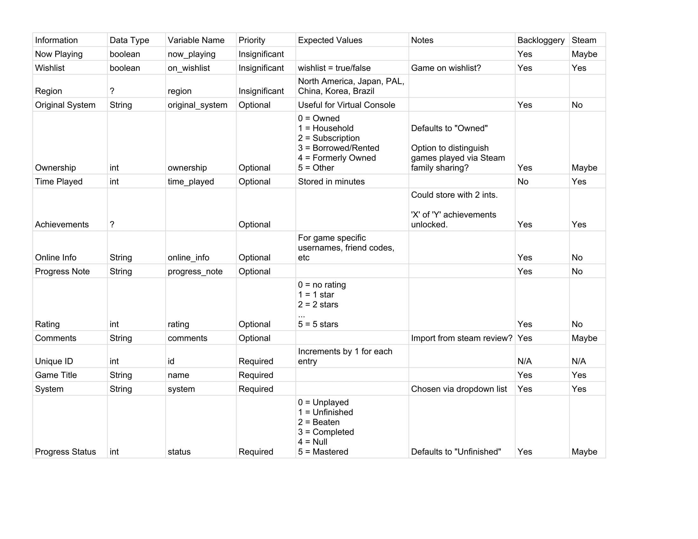

**Backloggery’s User Interface UI Sketch**

